Project Cover Sheet

Grade:

Course Code/Title: ME 323 / Mechanics of Materials

Section Number :

Instructor Name :

Semester/Year : Fall 2021-2022

Student Name(s) | Student Number

Contents

Abstract 2
Introduction 3
Problem definition 4
Sketch of the arm: 4
Solid work: 5
Maximum forces 5
Materials used 6
Material properties: 6
Work plan 7
Calculations: 7
Solid work simulation 15
Conclusion: 18
References 18

Figure 1: bicep\triceps machine 3
Figure 2: machine dimensions 3
Figure 3: 3D arm model 4
Figure 4: solid work simulation (stress) 13
Figure 5: solid work simulation(deflection) 13
Figure 6: solid work simulation (F.O.S.) 14

Table 1: Mechanical properties 5
Table 2: physical properties 5

Abstract

The main focus of our course project is a machine referred to as solid tricep/bicep machine. This project’s main objective is to foster the connection of real-life applications to material mechanics principles. The project's requirements will also be satisfied by presenting a complete analysis of stress and deflection to the metallic arm. The project will also show an overview in the application, functionality, types of materials used, the manufacturing process and mechanical properties, and the machine's solid work model. In this case, the second deliverable seeks to depict a broad spectrum of calculations for various stress types, deflection as well as the factor of safety.
Additionally, a solid work model will be simulated and then compared to the calculations done manually, followed by a broad discussion of the results. Through the second deliverable, we will calculate the stresses of different types obtained from the force applied. The selection of the maximum stress will calculate the factor of safety. Lastly, we will determine the different deflection types. For instance, we will calculate the deflection at point A resulting from transverse loading. Solid works stimulation will then be done and then compare the results with the calculations done manually and discussed widely.

Introduction

Bodybuilding has become a low-tech endeavor. Various bodybuilding machines exist which can now help individuals develop strong muscles and even burn excessive fat in the body. This project will examine the solid tricep/bicep machine. The triceps/bicep machine has an intelligent dual-function design that assists in developing bulged biceps and triceps. Moreover, the device improves the rear and upper arm muscles' fitness, meaning that it speeds up the time required to gain more muscular biceps and triceps. The upper arm is located between the shoulder joint and the elbow joint. It has two crucial muscles; the biceps on the anterior and the triceps on the posterior compartment. Since the muscles operate in agonist and antagonist fashion, training both of them is equally important. The triceps part from the biceps provides very smooth changes to triceps exercise. The machine has an adjustable seat and upper arm pad. This machine design allows for the alignment of the upper arm pad with the elbow. It also provides alignment with the lifting arm’s rotational axis. The handle of the machine pivots to ensure the user is comfortable.
On the triceps/biceps machine, both the triceps and biceps muscles need to act against each other for the elbow joint to be bend or be straightened. Biceps are the flexors while triceps are the extensors. For the elbow to bend, biceps need to contract. On the contrary, the triceps need to relax. Similarly, to straighten the arm, the triceps will have to contract while the biceps relaxes.
The machine has a chair of iron material with a sponge cover and the second layer of strong leather. Although other manufacturers use iron, many manufacturers use aluminium to make the machine's body, while others use the iron for both the seat and the body. Other materials used to manufacture the machine include stainless steel, carbon steel, copper, wood, and titanium. A sponge is added on the handle of the device to improve conform for the user.
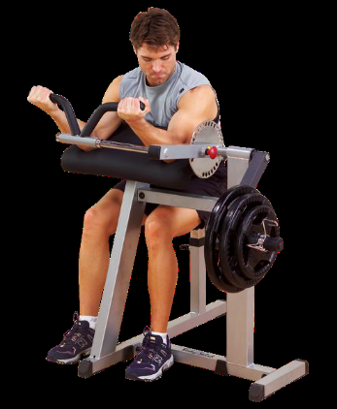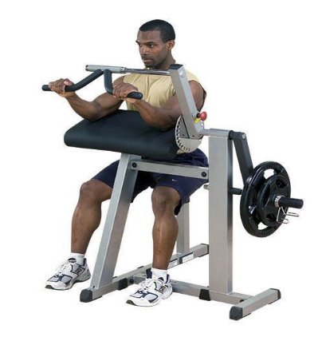

Problem definition

We were required to explore a bodybuilding machine in our project: the bicep/triceps machine. We will achieve this with the application of the knowledge gained in the coursework. First, we shall have to sketch the arm. Then, the 3d model of the arm will be designed with solid work software. This will then enable us to calculate the maximum stress on the arm and the machine's deflection factor of safety. The maximum forces that can be applied to the handles of the device will also be established. We shall also research on the most suitable materials for the arm of the machine. Ultimately, we will then compare the solid work model's simulation results compared to the manual calculations.

Sketch of the arm:

The group used the dimensions in Figure 2 to draw a solid work model. Although it lacked some measurements, they had to give an approximation to yield a complete 3D work model.
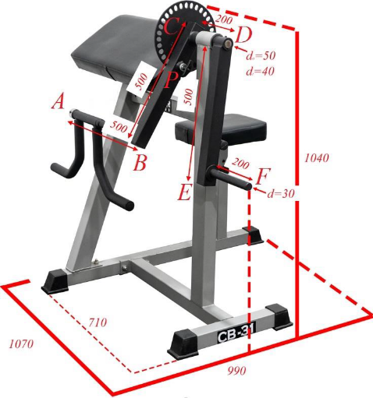
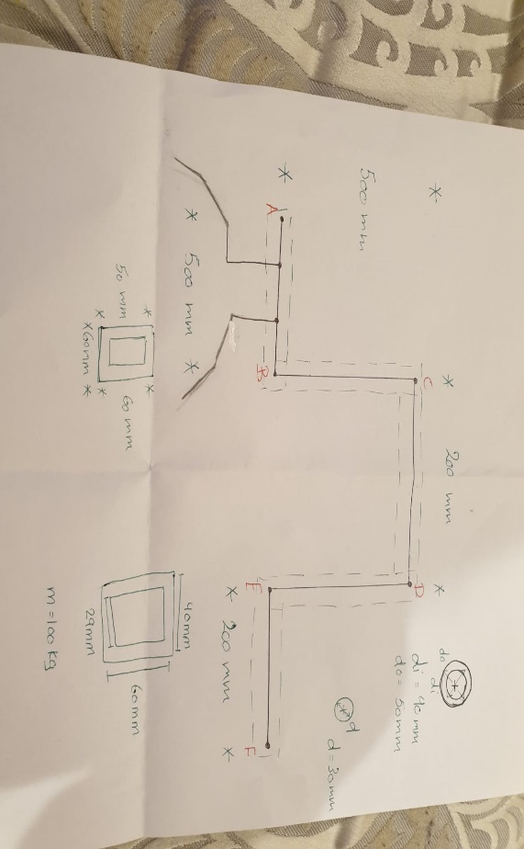
Figure 2: machine dimensions

Solid work:
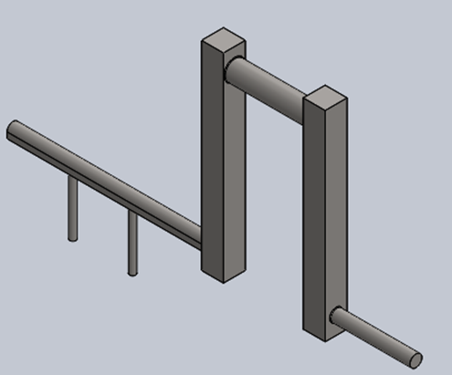
Figure 3: 3D arm model

Maximum forces

The maximum mass of the individual on the machine is a prerequisite when finding the maximum stress and the deflection forces on the device. Given a maximum mass of 140 Kg, we need to multiply it with the gravity constant, 9.81m/s², to get the individual's full weight. The machine will only have one shear stress, and thus the weight will be divided by one to obtain the maximum force exerted on the arm. We found the maximum force to be $1373$
The calculations are as follows: $\frac{140*9.81}{1}=1373$

Materials used

The adjustable arm pad of the machine has a round tube of hardened material. In most cases, another layer of leather gets added to cushion the hand while in use. Following our intensive research, we established that the most appropriate material used in manufacturing this machine is Carbon steel 1020. This is because of carbon's role in the carbon steels' machinability, including hardness, tensile and yield strength, ability to be welded, and ductility. Its applicability also gets enhanced due to their cold will be drawn or turned and polished finish properties. Due to its low carbon content, Carbon steel 1020 can be induction hardened. Cracking during treatment is rare. The material is cheap and safer, which formed the other reasons for the choice of the materials.

Material properties:

- Mechanical properties:
Table 1: Mechanical properties
Yield Strength ($σy$ ) | 350 Mpa
Shear modulus | 80 Gpa
Elastic modulus (E) | 205 Gpa
Tensile Strength ($σ_{T}$) | 420 Mpa

- Physical properties:
Table 2: physical properties
Mass Density (ρ) | 7870 kg/m³

Work plan

The average normal stress due to axial loading will be first obtained. The average shearing stress due to transverse loading, the maximum shearing stress due to the torsional load, and the maximum stresses due to the bending behaviour will then be calculated. The maximum normal and shear stresses will then be calculated and later find the machine's safety factor. Ultimately, the deflection at A is calculated.

Calculations:
Some dimensions and givens are provided from the sketch diagram below to make it easier to do the calculations. Therefore, we calculated the needed requirements by using the values given as a reference. The provided information is shown below:
Yield Strength ($σy$ ) = 350 MPa
Shear modulus (G) = 80 GPa
Elastic modulus (E) = 205 GPa
Tensile Strength ($σ_{T}$) = 420 MPa
Pin diameter=12 mm
Maximum force= 981 N
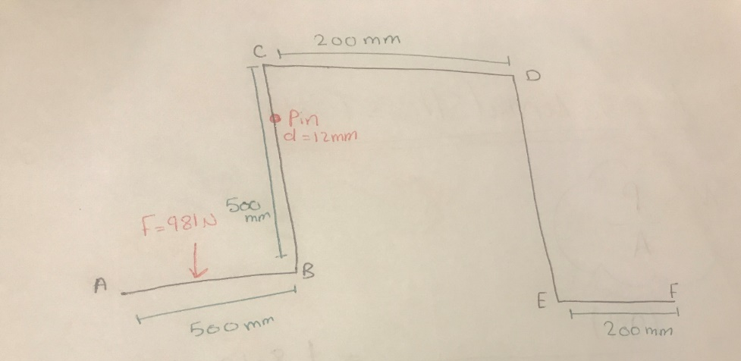

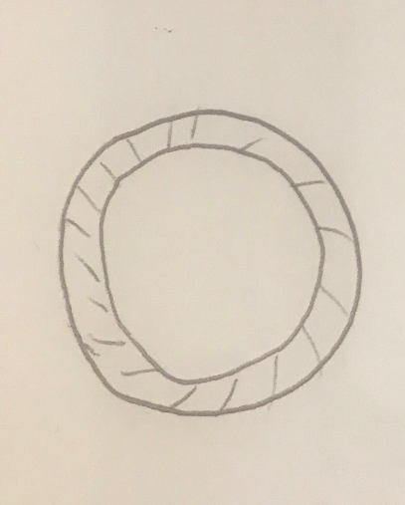
Points AB together with CD are hollow parts. The machine’s outer diameter = 50mm. The inner diameter = 40mm. the machine’s thickness = 5mm
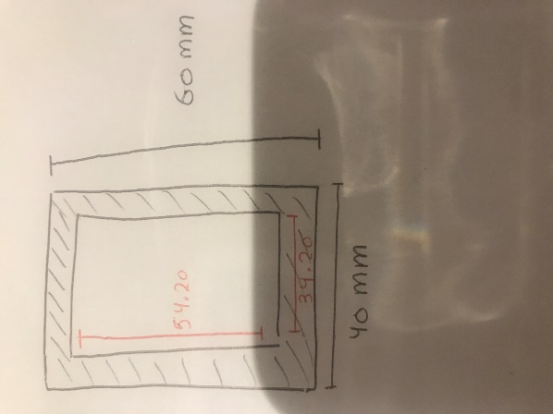
Parts BC together with D.E. which are also hollow and their thickness = 2.9mm
The inner rectangle: the length= 54.20 mm, width =34.20 mm. The outer rectangle: the length=60 mm and the width=40 mm as per the illustrations provided in the sketch above.
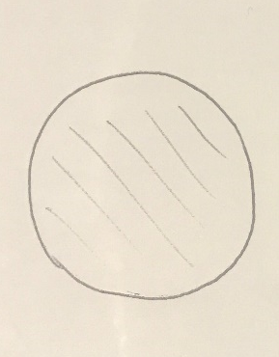

E.F. which is a solid, the diameter = 30 mm
- Average normal stress due to axial loading is calculated as:
$$σ=\frac{p}{A}$$

$σ \left(BC ,DE\right)=\frac{-981 }{\left(60*40\right)-(54.2*34.20)}=-1.8 MPa$ (Compression)
$$σ \left( AB\right)=\frac{981}{\frac{π}{4}*({50}^{2}-{40}^{2})}=1.40MPa$$
$$σ \left( EF\right)=\frac{981}{\frac{π}{4}*({30}^{2})}=1.40 MPa$$

- Mean shearing stress calculation:
$$τ=\frac{P}{n*A}$$
Single shear stress, therefore,
$$τ=\frac{981}{1*\frac{π}{4}*({12}^{2})}=8.71 MPa$$

- Maximum shearing stress as a result of torsional loading:
$$τ(hollow CD)=\frac{T*Co}{J}$$
To some information that is missing needs to be calculated first:
- T= $F*d$ = 981 $*\frac{500}{2}$ = 245.26 $*{10}^{3}$ N.mm
- Co = $\frac{do}{2}$ = $\frac{50}{2}$ = 25.0 mm
- Ci=$\frac{di}{2}$ = $\frac{40}{2}$ = 20.0 mm
- J= $\frac{π}{2}*\left({Co}^{4}-{Ci}^{4} \right)$= $\frac{π}{2}*\left({25}^{4}-{20}^{4} \right)$= 362.4 $*{10}^{3}$ ${mm}^{4}$

The maximum shearing stress due to torsional loading can now be calculated: $τ\left(hollow CD\right)=\frac{245.25*{10}^{3}*25}{ 362.4 *{10}^{3}}=16.96 MPa$

- Maximum normal stress as a result of bending behavior:
$$σm(CB)=\frac{M*C}{I}$$
Some information is missing thus needs to be calculated for use in the formula to get the maximum normal stress
- M= P* distance between the force to the body's center = $=981*\left(\frac{500}{2}-\frac{40}{2}\right)=264.87*{10}^{3} N.mm$

- Cx= 40/2 = 20.0 mm

- Iy= $\left(\frac{60*{40}^{3}}{12}-\frac{54.2*{34.20}^{3}}{12}\right)=139.3*{10}^{3 } mm^{4}$

Now we can get the Maximum normal stress due to bending behavior:
$$σm\left(CB\right)=\frac{264.87*{10}^{3}*20}{139.3*{10}^{3 }}=38.03 MPa$$

$$σm(ED)=\frac{M*C}{I}$$
- M= P* the distance between the force to the center of the body =
$981*\left(\frac{200}{2}-\frac{40}{2}\right)=117.71*{10}^{3} N.mm$

- Cx= 40/2 = 20 mm
- Iy= $\left(\frac{60*{40}^{3}}{12}-\frac{54.2*{34.20}^{3}}{12}\right)=139.3*{10}^{3 } mm^{4}$
$$σm\left(ED\right)=\frac{117.71*{10}^{3}*20}{139.3*{10}^{3 }}=16.96 MPa$$

Eccentric loading:
-Due to tension condition:
$σ=\frac{P}{A}+\frac{M*C}{I}$ = 1.8 + 38.02 = 39.82 MPa

- Due to compression loading:
$σ=\frac{P}{A}-\frac{M*C}{I}$ = 1.8 - 38.02 = -36.22 MPa

- Maximum normal and shear stress
- Maximum normal due to bending:
$σm=38.03 MPa$
- Maximum shear due to torsion:
$τ=16.96 MPa$

8. Machine’s safety factor:
- As a result of normal stress condition:
Factor of safety=$\frac{ultimate stress}{ allowable stress}$(normal)
F.O. S=$\frac{350}{38.03}=9.21$ due to bending
F.O. S=$\frac{350}{39.83}=8.81$ due to eccentric loading

- due to shear stress condition:
$$τyield=0.6*350=210 MPa$$

F.O.S=$\frac{ultimate shear stress}{ allowable shear stress}=\frac{210}{16.96}=12.41$
Upon calculating the factor of safety for normal and shear stress respectively, the aspect of safety is = 8.81 (this indicates a failure condition)

- Deflection at point A:
First of all, we need to calculate the moment around point B.
∑M=0
(-P*X) +M=0
M=P*X
The suitable equation is:
$$\frac{d^{2}y}{dx^{2}}=\frac{M\left(x\right)}{E*I}$$
$$\int{\frac{d^{2}y}{dx^{2}}=\frac{1}{E*I} \int{(P*X)}}$$

$$θ\left(x\right)=\frac{dy}{dx}=\frac{1}{E*I}\left(\frac{P*X^{2}}{2}+C1\right)$$
The slope equation (equation 1) is presented as:
$$\int{\frac{dy}{dx}}=\frac{1}{E*I}\int{(\frac{P*X^{2}}{2}+C1)}$$
$$Y\left(x\right)=\frac{1}{E*I}(\frac{P*X^{3}}{6}+C1*X+C2)$$
Deflection equation (equation 2) is therefore given below:

For point A:
XA=0
YA=EXIST
$θA$= EXIST

For point B:
X.B. =L
YB=0
$θB$= 0 (Fixed support)

From equation 1, point B:
0 =$\frac{1}{E*I}(\frac{P*L^{2}}{2}+C1)$
$$C1=-\frac{P*L^{2}}{2}$$

From equation 2, point B:
$$0=\frac{1}{E*I}(-\frac{P*L^{3}}{6}+\frac{P*L^{2}}{2}*L+C2)$$

$$C2=\frac{P*L^{3}}{3}$$

$$θ\left(x\right)=\frac{1}{E*}\left(\frac{ I.P.*X^{2}}{2}-\frac{P*L^{2}}{2}\right)$$

$$Y\left(x\right)=\frac{1}{E*I}(\frac{P*X^{3}}{6}-\frac{P*L^{2}}{2}*X+\frac{P*L^{3}}{3})$$

Deflection at point A (XA=0):
$$Y\left(A\right)=\frac{1}{E*I}(\frac{P*0^{3}}{6}+\frac{P*L^{2}}{2}*0+\frac{P*L^{3}}{3})$$

$$Y\left(A\right)=\frac{P*L^{3}}{3E*I}$$

$$Y\left(A\right)=\frac{981*({500)}^{3}}{3*200*{10}^{3}*\frac{π}{64}*\left({50}^{4}-{40}^{4}\right)}=1.14 mm$$
Point A moves upward
The slope at point A:
$$θ\left(A\right)=\frac{1}{E*I}\left(\frac{P*0}{2}-\frac{P*L^{2}}{2}\right)=-\frac{PL^{2}}{2*E*I}=\frac{981*{500}^{2}}{2*204.9*{10}^{3}*181.1*{10}^{3}}=-3.40*{10}^{-3} rad$$

- Axial deflection:
$$δ\left(BC,DE\right)=\frac{P*L}{E*A}=\frac{981*500}{205*{10}^{3}(\left(60*40\right)-\left(54.2*34.2\right))}=4.38*{10}^{-3} mm$$
K) Angle of twist:
$$∅=\frac{T*L}{G*J}=\frac{245.25*{10}^{3}*200}{80*{10}^{3}*362.3*{10}^{3}}=1.69*{10}^{-3} rad$$

Solid work simulation
We used solid work software in creating the arm and apply maximum force to it. We ran The simulation, and obtained the following results:
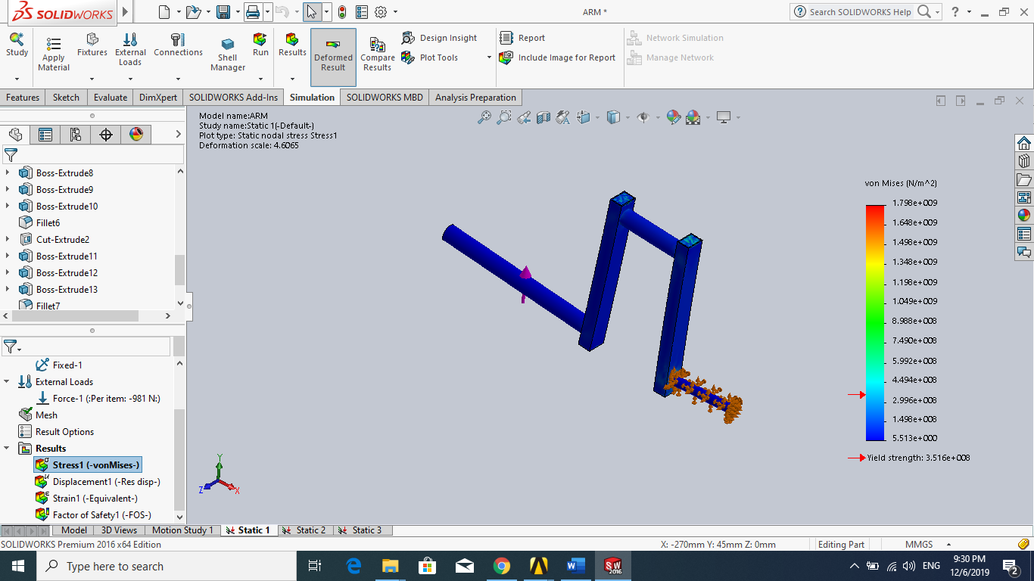
Figure 4: solid work simulation (stress)

Figure 4 shows that, maximum stress=$1.799*{10}^{9}$
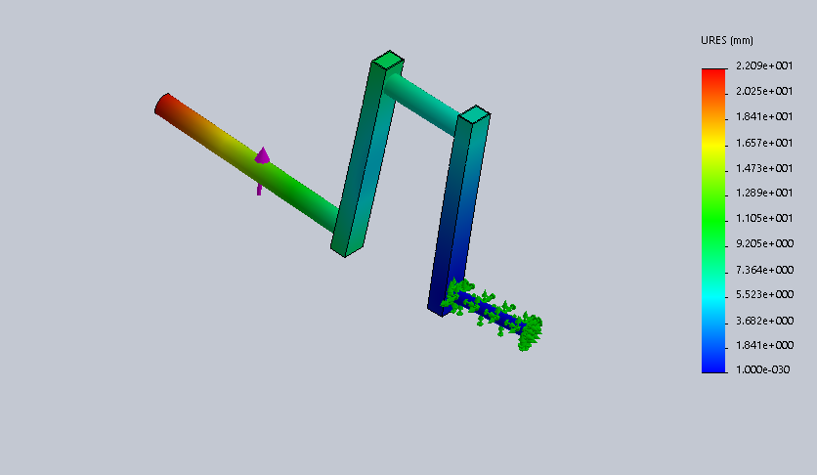

Figure 5: solid work simulation (deflection)
Figure 5 indicates that deflection=$2.20*{10}^{1}$

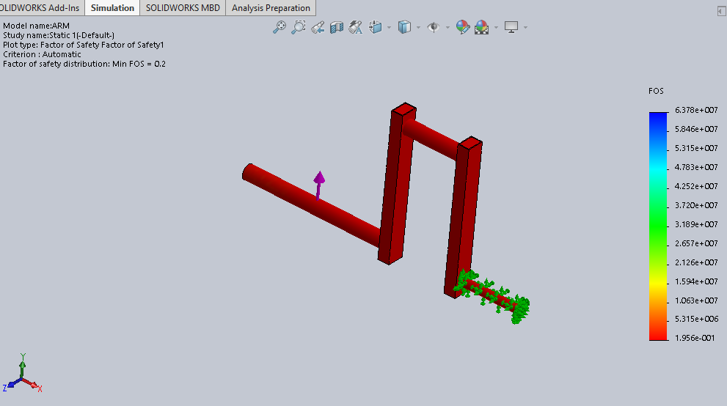

Figure 6: solid work simulation (factor of safety)

Figure 6 of the simulation depicts that the factor of safety= 0.20. It is safe since it should be greater than 1 for a secure machine.
From the simulation using the software, we realized that the machine was not safe enough, and the results between hand calculation and the results of the software simulation were different. We achieved the different results chiefly as the software was calculating von misses (3D, stresses). The hand calculations depend on plane stresses, but the solid work simulation software usually depends on 3D stresses. Therefore, the software’s accuracy is more than that of hand calculations. This is because the program usually takes the factor of the overall object.

Conclusion:
Conclusively, our group understood the issues pertaining to the bicep/tricep machine by mathematically studying its mechanical behaviour, and we were able to learn about the device better. In the long run, we acquired the ability to determine significantly the best material used to make the machine. This was achieved by the use of a simple equation to depict how the maximum force can be achieved, also assumption of some dimensions and as well as the ones given, a solid work model was created, a discussion was then conducted about our plan plan of working for achieving the next deliverable, in what were thus our final results achieved when the total forces learned in the course are determined.

References
https://www.azom.com/article.aspx?ArticleID=6114

